**Analog Devices transceiver solution enables WMAS-based Spectera ecosystem**

*By Dr Sebastian Georgi, Henryk Mironczuk and Matthew Hazel*

|  |  |
| --- | --- |
|  | *System engineer Dr Sebastian Georgi is one of the inventors of Sennheiser’s WMAS-based Spectera system. For more than a decade, he has been conducting research into wireless broadband techniques and how to specifically tailor them to professional audio applications. Georgi did his PhD thesis at Hamburg University of Technology in the field of OFDM.* |
| Ein Bild, das Menschliches Gesicht, Person, Kleidung, Kinn enthält.  KI-generierte Inhalte können fehlerhaft sein. | *Henryk Mironczuk is a Sr. Product Applications Manager at Analog Devices, Inc. Throughout his career at ADI, he has worked with various technologies, including micro-converters, audio/video products, RF tuners, highly integrated agile RF transceivers, and high-speed digitizers. He is a domain expert on complex transceiver and ADC/DAC products. Henryk holds a master’s degree from Wroclaw University of Technology. His in-depth knowledge of the ADRV9002 chip family and close cooperation with Sennheiser helped make WMAS a product.* |
| Ein Bild, das Menschliches Gesicht, Person, Lächeln, Kleidung enthält.  KI-generierte Inhalte können fehlerhaft sein. | *A graduate of the Worcester Polytechnic Institute (WPI), Matthew Hazel has worked at Analog Devices since 2006, in roles spanning Product Applications, System Architecture, and Marketing, and in technologies including Inertial MEMS, LIDAR, Automotive Battery Management and RF Integrated Transceivers. Matthew currently serves as the Sr. Product Marketing Manager for Multi-Market Transceivers, managing a portfolio of highly integrated RF transceivers for advanced communications capabilities. He focuses on developing strong customer relationships to drive the future of wireless communications, such as the WMAS high-performance audio solution from Sennheiser.* |

**Introduction**

Professional wireless microphones and in-ear monitors have long since become a standard in live music performances and prerequisite for the impressive stage shows that wow audiences across the globe. In this highly professional environment, engineers and performers must be able to fully rely on a combination of rock-solid wireless transmission and outstanding, low-latency audio quality.

Although wireless transmission protocols and standards have advanced in recent years, modern standards such as 4G LTE, 5G NR, Bluetooth and WiFi are unable to meet the stringent requirements for professional audio applications. Therefore, professional audio systems still rely on legacy narrowband standards, where a microphone continuously transmits on a dedicated frequency using 200 kHz of RF channel bandwidth, and a stationary rack-mount receiver set to the same frequency to receive the microphone signal. This one-on-one system topology is susceptible to interference both from external devices and from multi-path effects caused by the layout and structure of the venue.

To address these challenges and deliver a superior experience for its professional audio customers, Sennheiser has invested in the development of vendor-specific wireless transmission technologies for many years. With its WMAS-based Spectera ecosystem, Sennheiser is advancing the state of the art in professional wireless audio by achieving new levels of wireless performance and reliability, supported by the latest integrated transceiver technology from Analog Devices, Inc.

After years of research activities and standardization work, Sennheiser successfully managed to have Wireless Multichannel Audio Systems (WMAS) included in ETSI standardization in 2017. The transformation from analog frequency modulated (FM) transmission schemes to fully digital solutions had been achieved in the professional live audio industry a while ago, but modern multiple access and duplex schemes were still not available for professional wireless live audio applications — until Sennheiser’s Spectera bidirectional wideband wireless ecosystem started shipping in 2025. Spectera, which operates under the WMAS regulatory regime, represents the next evolutionary step for the professional audio industry: going from a simplex, link-oriented, connection-less and single-channel transmission scheme to — in the best case — a full-duplex, connection-oriented, multichannel wideband system.

Ein Bild, das Text, Screenshot, Schrift, Diagramm enthält.

Sennheiser WMAS and Spectera timeline

In the creation of Spectera, well established architectures, such as discrete super-heterodyne receiver structures, had to be abandoned in favor of bidirectional communication based on highly integrated transceiver solutions, such as the ADRV9002 RF transceiver chip family from Analog Devices, Inc (ADI).

The ADRV9002 chip family, which provides a system-on-chip solution that replaces as many as 20 high-performance discrete components and supports RF operation from 30 MHz to 6 GHz, is capable of handling narrowband and/or wideband signals from 12 kHz to 40 MHz. The collaboration between ADI and Sennheiser has proven that this chip meets the stringent requirements for professional wireless audio applications.

**Pro audio requirements on the ADI transceiver chip**

**RF blocking:** Mobile devices like beltpack receivers are especially prone to facing severe blocking scenarios of up to 10 dBm in adjacent channels when artists sing a duet, and antennas meet in near field proximity.

**Latency**: Professional live audio applications require a demanding latency of 1 ms for a continuously transmitted audio stream with a typical data rate of 250 kBit/s. To put things into perspective, a duration of only 250 bits is already equivalent to the latency limit. No standard, “off-the-shelf” wireless technology is able to provide such low latency in a reliable manner for multichannel audio applications. This is why proprietary, pro audio specific RF solutions are required.

**Reliability:** Professional wireless microphones and in-ear monitoring systems are at the beginning of the audio production chain, hence there is no margin for errors. Technologies such as automated repeat request (ARQ) are avoided for latency reasons. Therefore, physical layer stability requirements are high.

**Runtime and size:** Typical professional wireless microphone and in-ear monitoring applications demand a minimum of five hours of continuous audio transmission and reception. This operating time needs to be achieved in the small form factor of a beltpack or a handheld, which limits available battery capacity. Bidirectional operation combined with a small form factor makes the use of highly integrated RF transceiver solutions mandatory.

**Frequency resources:** Frequency resources previously allocated to TV broadcasting and professional wireless audio usage have been reallocated (i.e. the 800 MHz and 700 MHz bands, in the USA additionally the 600 MHz band), while the demand for spectrum has at the same time been increasing due to more events with higher complexity and bigger installations. Therefore, the professional audio industry has been looking for new ways to deal with the reduced frequency resources, by improving technology to enable new workflows and establish access to frequency ranges above 1 GHz. Enabling the use of configurable QoS tailored to the specific needs of the talent on stage is one key. Another key is the deployment of alternative frequency bands. To offer such solutions, an integrated, frequency-agile RF transceiver solution is mandatory for the professional audio industry.

**The solution — Analog Devices ADRV9003 transceiver chip**

Analog Devices’ ADRV9002 family of highly integrated transceivers enabled Sennheiser to develop a professional audio system that fulfills all necessary requirements, even in demanding radio environments. By delivering more than 150 dB of dynamic range, the ADRV9003 is ideally suited for professional and concert audio environments, even with heavily congested RF spectrum, as it can receive both blocking signals and desired signals simultaneously.

Ein Bild, das Elektronik, Schaltung, Elektronisches Bauteil, Elektrisches Bauelement enthält.

Analog Devices ADRV9002 evaluation board

In combination with its excellent linearity performance (IIP3=22 dBm at G=30 dB & NF=12 dB, linearity improves as gain reduces) and integrated low phase noise oscillators, the ADRV9003 decreases potential reciprocal mixing components, thereby mitigating the blocking signal’s contamination of the signal of interest. Finally, programmable, high-order digital filters precisely isolate the signal of interest so that it can be transmitted to the system processor. Through this combination of analog performance and integrated digital signal processing, the ADRV9003 effectively addresses the RF blocking challenge.

The ADRV9003 is the heart of the RF subsystem inside an orthogonal frequency division multiplexing (OFDM) based time division multiple access (TDMA) scheme.

The unique characteristics of Sennheiser’s RF protocol requires very agile operation of the RF frontend. The ADRV9003 with its internal blocks is optimized for deterministic and dynamic operation, and is capable of fulfilling the demanding requirements of this application. Switching between data reception and data transmission can be done in 4 µs, which helps fulfil the stringent latency requirements.

Reliable operation of the RF frontend is critical in WMAS applications. Utilizing ADI’s proven transceiver technology helps ensure the stability of the physical layer. Simplifying the bill of materials improves reliability and decreases pressure on the supply chain. Basing the solution on a single-chip transceiver that passes the rigorous manufacturing testing stages helps ensure overall system consistency. Programmability of the transceiver solution offers the option for future software upgrades to address potential issues or to deliver new features and enhance the user experience.

Thanks to a receiver architecture that relies on an internal high dynamic range, the constraints that are typically put on RF filtering are relaxed significantly. This allows implementation of a flexible and programmable RF solution to create one universal hardware that covers RF bands from 30MHz up to 6GHz.

To help with power saving requirements, the ADRV9003 offers the ability to dynamically power down its internal blocks. When utilizing one of these modes, waking up the receiver or transmitter data path together with its associated LO source can be done in 40 µs.

Last but not least, the RF configurability and agility of the ADRV9003 enables Sennheiser to future-proof its ecosystem, as the chip is capable of handling new RF bands that may become available in the future.

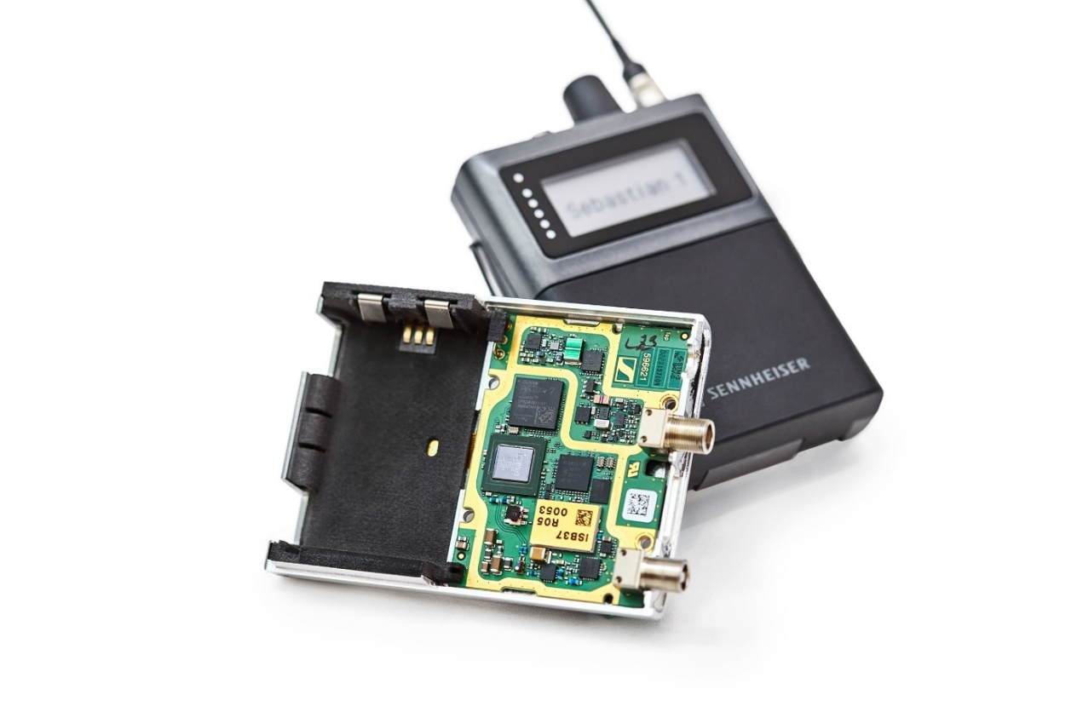

Sennheiser Spectera beltpack with Analog Devices ADRV9003 chip

**Conclusion**

As an innovation-leading manufacturer of professional wireless microphones and IEMs, Sennheiser has pioneered the concept of Wireless Multichannel Audio Systems (WMAS) since 2013, researching deeply into the technology and basing its prototypes on integrated transceivers from Analog Devices. The ADRV9003, which belongs to the latest generation of ADI’s RF-agile software-defined radio transceivers, has enabled Sennheiser and the industry to make WMAS a reality.

Sennheiser’s WMAS-based Spectera ecosystem empowers end users to significantly reduce their spectrum footprint if and where required, enabling the deployment of professional wireless audio solutions even in environments with very limited TV-UHF spectrum availability. At the same time, Spectera delivers substantial added value by offering unmatched system integration, exceptional audio quality, ultra-low latency transmission, comprehensive remote control, and flexibility for a wide range of applications and productions, including access to additional frequency bands above 1 GHz (as made available by national regulation) to compensate for the growing spectrum demand.